**Functional Specification**

**K1 Water Disinfection Generator**

**Project Manager: Rodney Herrington**

**David Kirby**

**Diego Chavez**

**University of New Mexico**

**School of Engineering**

**Aqua Research**

**5601 Midway Park Pl NE**

**Albuquerque, NM 87019**

**10/10/19**



|  |  |  |  |
| --- | --- | --- | --- |
| **REVISION HISTORY** | | | |
| **Name** | **Date** | **Changes** | **Version** |
| Diego | 10/27/2019 | Update from old documents | 2 |
|  |  |  |  |
|  |  |  |  |

Table of Contents

1 Introduction 3

1.1 Summary 4

1.2 Requirements 4

1.3 Numbers 4

1.4 Existing System 4

1.5 Terminology 4

1.6 References 4

2 Functional Description 4

2.1 Use Cases 6

2.2 User Community 6

2.3 Administration Functions 6

2.4 Error Handling 6

2.5 Security 7

2.6 Interfaces 7

2.6.1 User 7

2.6.2 Software 7

2.6.3 Hardware 7

2.6.4 Mechanical 7

2.7 Boundary Conditions 8

2.8 raints 8

2.9 Platforms 8

2.10 Internationalization 8

2.11 Performance 8

2.11.1 Capacity 8

2.11.2 Response times 9

2.12 Portability 9

2.13 Expandability 9

2.14 Customization 9

2.15 Support & Maintenance 9

2.16 Configuration Management 9

2.17 Documentation 9

3 Approvals 9

# **Introduction**

Chlorine can be made cheaply and effectively by using electrolysis of a saltwater brine solution with common salt and power as the only consumables for this project. The Chlorine can then be used to disinfect water in remote or low-income areas. The system built needs to be portable, durable, and self-sufficient. It must be able to recover from power disruptions and able to communicate system status through alarm conditions.

## Summary

The K1 Chlorine Generator is a tool that uses sodium-hypochlorite to purify gallons of water per day. This tool will achieve its full potential in emerging countries and low-income areas due to the low-cost investment and overall easy productivity.

## Requirements

While designing this tool it is important to consider stable software that can manage the overall system, have an interface, and be able to detect defects and send immediate alerts when a malfunction occurs. These specific documents have been sent by the sponsor and can be seen in the appendix.

## Numbers

The K1 chlorine generation system will be connected to an outside water source and be fairy self-sufficient with the intake and outtake of chlorine; making it easy for a small group of individuals to run the tool. Training will be simple for those especially in facilities under military and rescue operations, outdoor markers, and other industrial applications.

## Existing System

The K1 is the first model of its generation therefor there is no documentation of previous revision for the tool. There is however a previous team which developed software for this device.

## Terminology

K1 - 1 kg/day of hypochlorite-based mixed-oxidant solution produced

K2 - 2 kg/day of hypochlorite-based mixed-oxidant solution produced

## References

* DESIGN CRITERIA K1 061915
* Energy Calculations K1 & K2
* K1 MOS Draft Specifications 101413
* K1-K2 System BOM 111414
* Meanwell HLG-600H-spec
* System Layouts 1214
* Valve Granzow 025 120vac brass
* K1 Process and Instrument Diagram
* Project Description UNC K1 controls 0815
* K1 TECH BRIEFING 082615 Aqua Research

# **Functional Description**

While using the K1 it is important to know these functions:

* Turn on the power and ensure that the ventilation fan power is on.
* Locate brine tank to electrolyte tank and open solenoid value EOV 003.
* Once electrolyte tank brine switch is turned on close the solenoid valve EOV 003
* Open solenoid valve EOV 001 going from water source to electrolyte tank.
* Once the electrolyte tank water switch is activated close the solenoid valve EOV 001.
* Turn on power to electrolytic cell
* Monitor cell amperage. If amperage high, open solenoid value until it is at the appropriate level. If amperage is too low, open solenoid until it is at the appropriate level.
* Continue to keep power consistent in order to receive predetermined number of amp seconds.
* Once peak of amp seconds has been achieved, power off electrolytic cell.
* Open the solenoid valve EOV 002 in order to get predetermined number of seconds from electrolyte tank to oxidant tank.
* Once peak of number of seconds is reached close solenoid valve EOV 002
* Continue to repeat these steps until the oxidant tank switch is activated.
* When high level oxidant tank switch is activated, stop chlorine generation process.
* When low level oxidant tank switch is activated, start chlorine generations.
* During the 10 tenth cycle once the electrolyte tank is full, reverse polarity of cell for five minutes and then switch back to normal polarity until the finish of the cycle. Be sure to keep track of all cycles during this time.
* In the circumstance power is interrupted to the K1 system, the operator must save the accumulated amp-seconds and continue on the cycle once the power is back on. The operator is in charge of sending out notifications that the system is under maintenance at this time.
* Monitor Discrete and Analog inputs and outputs of system:
  + Discrete Inputs:
    - Oxidant Tank Level Switch High
    - Oxidant Tank Level Switch High High
    - Oxidant Tank Level Switch Low
    - Oxidant Tank Level Switch Low Low
    - Internal Run/Standby Switch
    - Electrolyte tank brine level switch
    - Electrolyte tank water level switch
    - Electrolyte tank high high switch
    - Cell Power Supply status
* Discrete Outputs:
  + - Electrolyte tank drain solenoid
    - Water solenoid valve
    - Internal Indicator Light Red input
    - Internal Indicator Light Green input
    - Internal Indicator Light Yellow input
    - External Alarm Output switch
    - Cell Power Enable
    - Brine solenoid valve
  + Analog Inputs:
    - Current sensor #1 (0-4V) = (0-50A)
    - Cell Voltage (0-10V) = (0–50V)

## Use Cases

[Need of update]

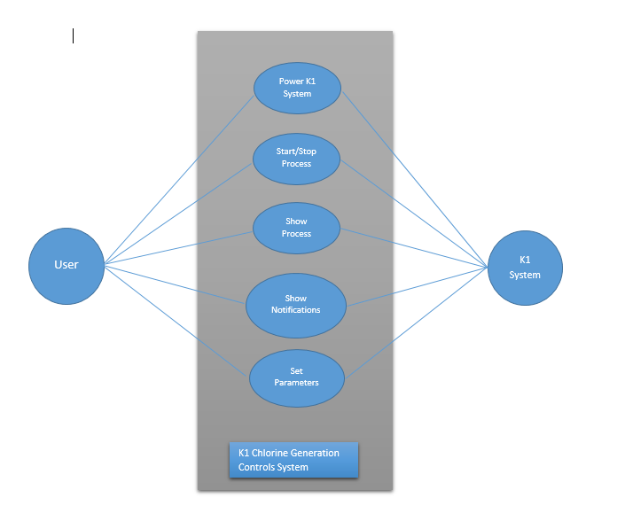

## User Community

This tool can be widely used anywhere but the gear is towards underdeveloped or disaster-stricken countries and/or areas. The main goal is to provide clean and safe water while being environmentally friendly. The K1 has been designed so that individuals without a technical background are able to upkeep the operation.

## Administration Functions

The K1 is dependent on the Human Machine Interface meaning that any operator can access the functions of the tool. In cases where passwords are needed to operate the K1 the individual with technical knowledge will oversee the changes.

## Error Handling

The central control system will be sent out via a ethernet error message prompted by the user if an error were to occur.

## Security

At this time no security measures have not been implemented to the system. However, an implementation is planned as an error message will be sent via ethernet. This will take form of an SSL encryption and acceptance of connection for only one static IP address.

## Interfaces

### User

The gear for this tool is to make it use friendly to those with no prior technical knowledge for them to be able to interact efficiently with the K1 control system. The tool will primarily be used in third world countries when technical training and education is limited. With the simplicity of the design the operator will oversee filling the tank with salt and pressing the start button.

If, at any point, the system required maintenance, a message will be received by the operator and displayed. With the diagnostics of the system an individual with basic knowledge of the K1 will be able to replace parts as needed.

### Software

Previous software or interfacing has been developed for the first model of the K1 control system. This software will need to be rewritten in C and updated to for efficiency and final implementation.

### Hardware

All hardware has already been chosen and assembled in a custom manner. These parts will be ordered: Arduino UNO R3 microcontroller, Arduino GSM Shield module. This module will be able to send of the SMS messages and simple displays for the interface of the human machine.

### Mechanical

The control system will be able to record input and output from the hardware; level switches, power supply, solenoid valves, and internal indicator lights as can be seen below.

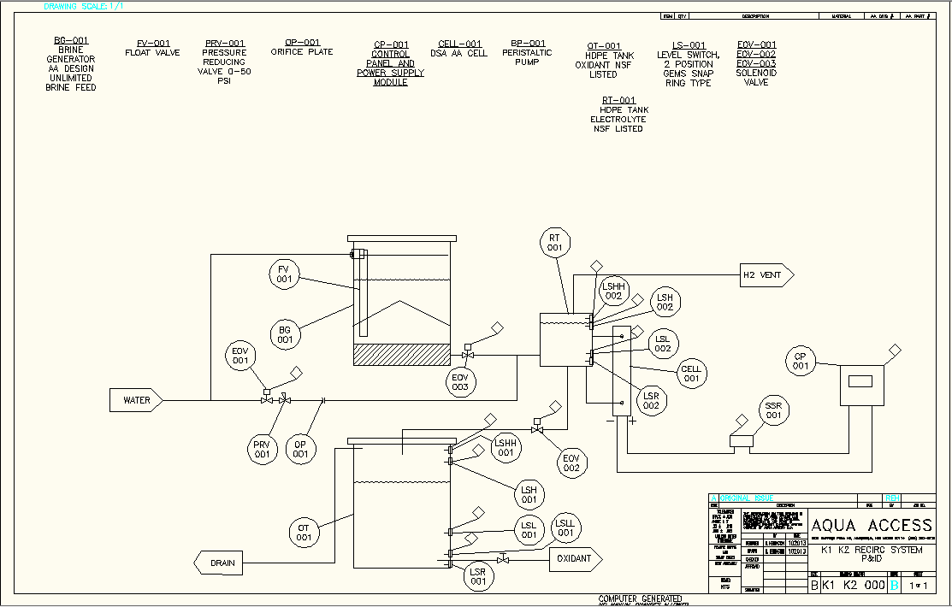

## Boundary Conditions

In the circumstance where the device detects lack of salt and alarm will be sent meaning it is necessary for the operator to add salt into device.

In the circumstance the system loses required energy of 110 or 220 VAC source, 50/60 Hz than alarms will be sent via SMS system. If there is no signal in the environment than the user will be unable to receive the alarm.

## Constraints

There are no constraints at this time.

## Platforms

Arduino Uno Rev 3 or equivalent

## Internationalization

    The K1 Chlorine Generator is a device that can be used and sold worldwide with the primary gear towards third world and/or underdeveloped countries.

## Performance

### Capacity

*And etc.*

### Response times

## Portability

Only one platform will be available for this device

## Expandability

At this time, there is no plan for expansion.

## Customization

At this time, there is no plan for customization.

## Support & Maintenance

If an issue were to occur, SMS alerts will be the first step of support for the operator to provide proper maintenance.

## Configuration Management

This project is based off one version.

## Documentation

Software Logic Description and Software Source Code Description

# **Approvals**

**The signatures of the people below indicate an understanding in the purpose and content of this document by those signing it.  By signing this document, you indicate that you approve of the proposed project outlined in this Functional Specification and that the next steps may be taken to proceed with the project.**

|  |  |  |  |
| --- | --- | --- | --- |
| **Approver Name** | **Title** | **Signature** | **Date** |
| **Rodney Herrington** | **Sponsor** |  |  |
| **Ramiro Jordan** | **Instructor** |  |  |
| **Ravinder Jain** | **Instructor** |  |  |